**INDEX**

**Content**   **Page no**

1. Introduction to Grocery Store Web Application 2
2. Need Of Grocery Store Web Application 2
3. Data Flow Diagram 3
4. Flow Chart 4
5. Coding Of HTML File 4 – 15
6. Coding of CSS file 16- 29
7. Coding of JavaScript File 30- 31
8. Delivery ( OUTPUT Screenshot ) 32-36
9. Bibliography 36

# *Grocery Store*

A **grocery store** or **grocery shop** or simply **grocery** is a store that primarily retails a general range of food products,which may be fresh or packaged. In everyday U.S. usage, however, "grocery store" is a synonym for supermarket, and is not used to refer to other types of stores that sell **groceries**. In the UK, shops that sell food are distinguished as grocers or grocery shops (though in everyday use, people usually use either the term "supermarket" or a "corner shop" or "convenience shop").

Larger types of stores that sell groceries, such as supermarkets and hypermarkets, usually stock significant amounts of non-food products, such as clothing and household items. Small grocery stores that sell mainly fruit and vegetables are known as greengrocers (Britain) or produce markets (U.S.), and small grocery stores that predominantly sell prepared food, such as candy and snacks, are known as convenience shops or delicatessens.

A typical **grocery** store is a retail store for households’ kitchen requirements such as pulses, rice, wheat, spices, etc, household plastics mugs, brush, buckets, etc and other household requirements such as detergent, sanitizing liquids, soaps, toothpaste, bathroom, and toilet cleaners, etc.

## Need of Grocery Store:-

**Everybody needs to eat**, which is why grocery stores are an essential part of any community and the US grocery market is worth three-quarters of a trillion dollars, and growing. You can start your own grocery store and grab a share of that huge market while providing a valuable service to friends and neighbours.

## Data Flow Diagram of Grocery Store:-

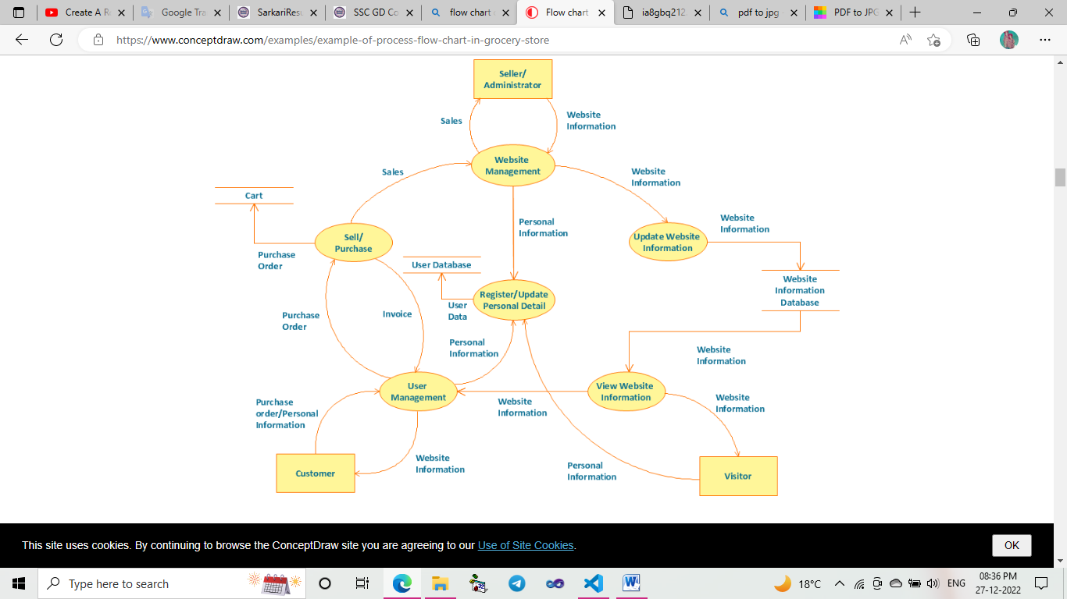

# *Coding :-*

## Flow Chart:-

* Coding on Visual Studio Code Platform.

## HTML File –

<!DOCTYPE html>

<html lang="en">

<head>

    <meta charset="UTF-8">

    <meta http-equiv="X-UA-Compatible" content="IE=edge">

    <meta name="viewport" content="width=device-width, initial-scale=1.0">

    <title>Complete Responsive Grocery Website Design Tutorial</title>

<link rel="stylesheet" href="https://unpkg.com/swiper@7/swiper-bundle.min.css" />

    <!-- font awesome cdn link  -->

    <link rel="stylesheet" href="https://cdnjs.cloudflare.com/ajax/libs/font-awesome/5.15.4/css/all.min.css">

    <!-- custom css file link  -->

    <link rel="stylesheet" href="css/style.css">

</head>

<body>

<!-- header section starts  -->

<header class="header">

    <a href="#" class="logo"> <i class="fas fa-shopping-basket"></i> groco </a>

    <nav class="navbar">

        <a href="#home">home</a>

        <a href="#features">features</a>

        <a href="#products">products</a>

        <a href="#categories">categories</a>

        <a href="#review">review</a>

        <a href="#blogs">blogs</a>

    </nav>

    <div class="icons">

        <div class="fas fa-bars" id="menu-btn"></div>

        <div class="fas fa-search" id="search-btn"></div>

        <div class="fas fa-shopping-cart" id="cart-btn"></div>

        <div class="fas fa-user" id="login-btn"></div>

    </div>

    <form action="" class="search-form">

        <input type="search" id="search-box" placeholder="search here...">

        <label for="search-box" class="fas fa-search"></label>

    </form>

    <div class="shopping-cart">

        <div class="box">

            <i class="fas fa-trash"></i>

            <img src="image/cart-img-1.png" alt="">

            <div class="content">

                <h3>watermelon</h3>

  <span class="price">$4.99/-</span>

                <span class="quantity">qty : 1</span>

            </div>

        </div>

        <div class="box">

            <i class="fas fa-trash"></i>

            <img src="image/cart-img-2.png" alt="">

            <div class="content">

                <h3>onion</h3>

                <span class="price">$4.99/-</span>

                <span class="quantity">qty : 1</span>

            </div>

        </div>

        <div class="box">

            <i class="fas fa-trash"></i>

            <img src="image/cart-img-3.png" alt="">

            <div class="content">

                <h3>chicken</h3>

                <span class="price">$4.99/-</span>

                <span class="quantity">qty : 1</span>

            </div>

        </div>

        <div class="total"> total : $19.69/- </div>

        <a href="#" class="btn">checkout</a>

    </div>

    <form action="" class="login-form">

        <h3>login now</h3>

        <input type="email" placeholder="your email" class="box">

        <input type="password" placeholder="your password" class="box">

        <p>forget your password <a href="#">click here</a></p>

        <p>don't have an account <a href="#">create now</a></p>

        <input type="submit" value="login now" class="btn">

    </form>

</header>

<!-- header section ends -->

<!-- home section starts  -->

<section class="home" id="home">

    <div class="content">

        <h3>fresh and <span>organic</span> products for your</h3>

        <p>Lorem ipsum dolor sit amet consectetur adipisicing elit. Aliquam libero nostrum veniam facere tempore nisi.</p>

    <a href="#" class="btn">shop now</a>

    </div>

</section>

<!-- home section ends -->

<!-- features section starts  -->

<section class="features" id="features">

    <h1 class="heading"> our <span>features</span> </h1>

    <div class="box-container">

        <div class="box">

            <img src="image/feature-img-1.png" alt="">

            <h3>fresh and organic</h3>

            <p>Lorem, ipsum dolor sit amet consectetur adipisicing elit. Deserunt, earum!</p>

            <a href="#" class="btn">read more</a>

        </div>

        <div class="box">

            <img src="image/feature-img-2.png" alt="">

            <h3>free delivery</h3>

            <p>Lorem, ipsum dolor sit amet consectetur adipisicing elit. Deserunt, earum!</p>

            <a href="#" class="btn">read more</a>

        </div>

        <div class="box">

            <img src="image/feature-img-3.png" alt="">

            <h3>easy payments</h3>

            <p>Lorem, ipsum dolor sit amet consectetur adipisicing elit. Deserunt, earum!</p>

            <a href="#" class="btn">read more</a>

        </div>

    </div>

</section>

<!-- features section ends -->

<!-- products section starts  -->

<section class="products" id="products">

    <h1 class="heading"> our <span>products</span> </h1>

    <div class="swiper product-slider">

        <div class="swiper-wrapper">

            <div class="swiper-slide box">

                <img src="image/product-1.png" alt="">

                <h3>fresh orange</h3>

                <div class="price"> $4.99/- - 10.99/- </div>

                <div class="stars">

                    <i class="fas fa-star"></i>

                    <i class="fas fa-star"></i>

                    <i class="fas fa-star"></i>

                    <i class="fas fa-star"></i>

                    <i class="fas fa-star-half-alt"></i>

                </div>

                <a href="#" class="btn">add to cart</a>

            </div>

            <div class="swiper-slide box">

                <img src="image/product-2.png" alt="">

                <h3>fresh onion</h3>

                <div class="price"> $4.99/- - 10.99/- </div>

                <div class="stars">

                    <i class="fas fa-star"></i>

                    <i class="fas fa-star"></i>

                    <i class="fas fa-star"></i>

                    <i class="fas fa-star"></i>

                    <i class="fas fa-star-half-alt"></i>

                </div>

                <a href="#" class="btn">add to cart</a>

            </div>

            <div class="swiper-slide box">

                <img src="image/product-3.png" alt="">

                <h3>fresh meat</h3>

                <div class="price"> $4.99/- - 10.99/- </div>

                <div class="stars">

                    <i class="fas fa-star"></i>

                    <i class="fas fa-star"></i>

                    <i class="fas fa-star"></i>

                    <i class="fas fa-star"></i>

                    <i class="fas fa-star-half-alt"></i>

                </div>

<a href="#" class="btn">add to cart</a>

            </div>

            <div class="swiper-slide box">

                <img src="image/product-4.png" alt="">

                <h3>fresh cabbage</h3>

                <div class="price"> $4.99/- - 10.99/- </div>

                <div class="stars">

                    <i class="fas fa-star"></i>

                    <i class="fas fa-star"></i>

                    <i class="fas fa-star"></i>

                    <i class="fas fa-star"></i>

                    <i class="fas fa-star-half-alt"></i>

                </div>

                <a href="#" class="btn">add to cart</a>

            </div>

        </div>

    </div>

    <div class="swiper product-slider">

        <div class="swiper-wrapper">

            <div class="swiper-slide box">

                <img src="image/product-5.png" alt="">

                <h3>fresh potato</h3>

                <div class="price"> $4.99/- - 10.99/- </div>

                <div class="stars">

                    <i class="fas fa-star"></i>

                    <i class="fas fa-star"></i>

                    <i class="fas fa-star"></i>

                    <i class="fas fa-star"></i>

                    <i class="fas fa-star-half-alt"></i>

                </div>

                <a href="#" class="btn">add to cart</a>

            </div>

            <div class="swiper-slide box">

                <img src="image/product-6.png" alt="">

                <h3>fresh avocado</h3>

                <div class="price"> $4.99/- - 10.99/- </div>

                <div class="stars">

                    <i class="fas fa-star"></i>

                    <i class="fas fa-star"></i>

                    <i class="fas fa-star"></i>

<i class="fas fa-star"></i>

                    <i class="fas fa-star-half-alt"></i>

                </div>

                <a href="#" class="btn">add to cart</a>

            </div>

            <div class="swiper-slide box">

                <img src="image/product-7.png" alt="">

                <h3>fresh carrot</h3>

                <div class="price"> $4.99/- - 10.99/- </div>

                <div class="stars">

                    <i class="fas fa-star"></i>

                    <i class="fas fa-star"></i>

                    <i class="fas fa-star"></i>

                    <i class="fas fa-star"></i>

                    <i class="fas fa-star-half-alt"></i>

                </div>

                <a href="#" class="btn">add to cart</a>

            </div>

            <div class="swiper-slide box">

                <img src="image/product-8.png" alt="">

                <h3>green lemon</h3>

                <div class="price"> $4.99/- - 10.99/- </div>

                <div class="stars">

                    <i class="fas fa-star"></i>

                    <i class="fas fa-star"></i>

                    <i class="fas fa-star"></i>

                    <i class="fas fa-star"></i>

                    <i class="fas fa-star-half-alt"></i>

                </div>

                <a href="#" class="btn">add to cart</a>

            </div>

        </div>

    </div>

</section>

<!-- products section ends -->

<!-- categories section starts  -->

<section class="categories" id="categories">

    <h1 class="heading"> product <span>categories</span> </h1>

    <div class="box-container">

        <div class="box">

            <img src="image/cat-1.png" alt="">

            <h3>vegitables</h3>

            <p>upto 45% off</p>

            <a href="#" class="btn">shop now</a>

        </div>

        <div class="box">

            <img src="image/cat-2.png" alt="">

            <h3>fresh fruits</h3>

            <p>upto 45% off</p>

            <a href="#" class="btn">shop now</a>

        </div>

        <div class="box">

            <img src="image/cat-3.png" alt="">

            <h3>dairy products</h3>

            <p>upto 45% off</p>

            <a href="#" class="btn">shop now</a>

        </div>

        <div class="box">

            <img src="image/cat-4.png" alt="">

            <h3>fresh meat</h3>

            <p>upto 45% off</p>

            <a href="#" class="btn">shop now</a>

        </div>

    </div>

</section>

<!-- categories section ends -->

<!-- review section starts  -->

<section class="review" id="review">

    <h1 class="heading"> customer's <span>review</span> </h1>

    <div class="swiper review-slider">

        <div class="swiper-wrapper">

            <div class="swiper-slide box">

                <img src="image/ckcimg.jpeg" alt="">

                <p>Here, All Types Of Grocery Available, i.e. Onion , Potato, Orange Etc.I suggest all person to buy the grocery from this website. Thank you </p>

                <h3>Chanchal Kumar Chiranjivi</h3>

                <div class="stars">

                    <i class="fas fa-star"></i>

                    <i class="fas fa-star"></i>

                    <i class="fas fa-star"></i>

                    <i class="fas fa-star"></i>

                    <i class="fas fa-star-half-alt"></i>

                </div>

                <div class="swiper-slide box">

                <img src="image/ckcimg.jpeg" alt="">

                <p>Here, All Types Of Grocery Available, i.e. Onion , Potato, Orange Etc.I suggest all person to buy the grocery from this website. Thank you </p>

                <h3>Chanchal Kumar Chiranjivi</h3>

                <div class="stars">

                    <i class="fas fa-star"></i>

                    <i class="fas fa-star"></i>

                    <i class="fas fa-star"></i>

                    <i class="fas fa-star"></i>

                    <i class="fas fa-star-half-alt"></i>

                </div>

            </div>

            <div class="swiper-slide box">

                <img src="image/pic-2.png" alt="">

                <p>Lorem ipsum dolor sit, amet consectetur adipisicing elit. Unde sunt fugiat dolore ipsum id est maxime ad tempore quasi tenetur.</p>

                <h3>john deo</h3>

                <div class="stars">

                    <i class="fas fa-star"></i>

                    <i class="fas fa-star"></i>

                    <i class="fas fa-star"></i>

                    <i class="fas fa-star"></i>

                    <i class="fas fa-star-half-alt"></i>

                </div>

            </div>

            <div class="swiper-slide box">

                <img src="image/pic-3.png" alt="">

                <p>Lorem ipsum dolor sit, amet consectetur adipisicing elit. Unde sunt fugiat dolore ipsum id est maxime ad tempore quasi tenetur.</p>

                <h3>john deo</h3>

                <div class="stars">

                    <i class="fas fa-star"></i>

                    <i class="fas fa-star"></i>

                    <i class="fas fa-star"></i>

                    <i class="fas fa-star"></i>

                    <i class="fas fa-star-half-alt"></i>

                </div>

            </div>

            <div class="swiper-slide box">

                <img src="image/pic-4.png" alt="">

                <p>Lorem ipsum dolor sit, amet consectetur adipisicing elit. Unde sunt fugiat dolore ipsum id est maxime ad tempore quasi tenetur.</p>

                <h3>john deo</h3>

                <div class="stars">

                    <i class="fas fa-star"></i>

                    <i class="fas fa-star"></i>

                    <i class="fas fa-star"></i>

                    <i class="fas fa-star"></i>

                    <i class="fas fa-star-half-alt"></i>

                </div>

            </div>

        </div>

    </div>

</section>

<!-- review section ends -->

<!-- blogs section starts  -->

<section class="blogs" id="blogs">

    <h1 class="heading"> our <span>blogs</span> </h1>

    <div class="box-container">

        <div class="box">

            <img src="image/blog-1.jpg" alt="">

            <div class="content">

                <div class="icons">

                    <a href="#"> <i class="fas fa-user"></i> by user </a>

                    <a href="#"> <i class="fas fa-calendar"></i> 27 Dec, 2022 </a>

                </div>

                <h3>fresh and organic vegitables and fruits</h3>

                <p>Lorem ipsum dolor sit amet consectetur adipisicing elit. Veniam, expedita.</p>

                <a href="#" class="btn">read more</a>

            </div>

        </div>

        <div class="box">

            <img src="image/blog-2.jpg" alt="">

            <div class="content">

                <div class="icons">

                    <a href="#"> <i class="fas fa-user"></i> by user </a>

                    <a href="#"> <i class="fas fa-calendar"></i> 27 Dec, 2022 </a>

                </div>

                <h3>fresh and organic vegitables and fruits</h3>

                <p>Lorem ipsum dolor sit amet consectetur adipisicing elit. Veniam, expedita.</p>

                <a href="#" class="btn">read more</a>

            </div>

        </div>

        <div class="box">

            <img src="image/blog-3.jpg" alt="">

            <div class="content">

                <div class="icons">

                    <a href="#"> <i class="fas fa-user"></i> by user </a>

                    <a href="#"> <i class="fas fa-calendar"></i> 27 Dec, 2022 </a>

                </div>

                <h3>fresh and organic vegitables and fruits</h3>

                <p>Lorem ipsum dolor sit amet consectetur adipisicing elit. Veniam, expedita.</p>

                <a href="#" class="btn">read more</a>

            </div>

        </div>

    </div>

</section>

<!-- blogs section ends -->

<!-- footer section starts  -->

<section class="footer">

    <div class="box-container">

        <div class="box">

            <h3> groco <i class="fas fa-shopping-basket"></i> </h3>

            <p>Here, All types of Grocery available, i.e. Onion , potato, Orange etc.</p>

            <div class="share">

                <a href="https://www.facebook.com/" target="_blank" class="fab fa-facebook-f"></a>

                <a href="https://www.twitter.com" target="_blank" class="fab fa-twitter"></a>

                <a href="https://www.instagram.com/" class="fab fa-instagram" target="_blank"></a>

                <a href="https://in.linkedin.com/" class="fab fa-linkedin" target="_blank"></a>

            </div>

        </div>

        <div class="box">

            <h3>contact info</h3>

            <a href="#" class="links"> <i class="fas fa-phone"></i>+91 9470282417 </a>

            <a href="#" class="links"> <i class="fas fa-phone"></i>+91 7903678881 </a>

            <a href="#" class="links"> <i class="fas fa-envelope"></i> chanchalkumarchiranjivi07@gmail.com </a>

            <a href="#" class="links"> <i class="fas fa-map-marker-alt"></i> Marwari College Bhagalpur, Bihar, 812007 </a>

        </div>

        <div class="box">

            <h3>quick links</h3>

            <a href="#" class="links"> <i class="fas fa-arrow-right"></i> home </a>

            <a href="#" class="links"> <i class="fas fa-arrow-right"></i> features </a>

            <a href="#" class="links"> <i class="fas fa-arrow-right"></i> products </a>

            <a href="#" class="links"> <i class="fas fa-arrow-right"></i> categories </a>

            <a href="#" class="links"> <i class="fas fa-arrow-right"></i> review </a>

            <a href="#" class="links"> <i class="fas fa-arrow-right"></i> blogs </a>

        </div>

        <div class="box">

            <h3>newsletter</h3>

            <p>subscribe for latest updates</p>

            <input type="email" placeholder="your email" class="email">

            <input type="submit" value="subscribe" class="btn">

            <img src="image/payment.png" class="payment-img" alt="">

        </div>

    </div>

    <div class="credit"> created by <span>Mr. C.K.Chiranjivi </span> | all rights reserved </div>

</section>

<!-- footer section ends -->

<script src="https://unpkg.com/swiper@7/swiper-bundle.min.js"></script>

<!-- custom js file link  -->

<script src="js/javascriptfile.js"></script>

</body>

</html>

SaveAs :- **Grocery.htm**

## CSS File :-

@import url('https://fonts.googleapis.com/css2?family=Poppins:wght@100;300;400;500;600&display=swap');

:root{

    --orange:#ff7800;

    --black:#130f40;

    --light-color:#666;

    --box-shadow:0 .5rem 1.5rem rgba(0,0,0,.1);

    --border:.2rem solid rgba(0,0,0,.1);

    --outline:.1rem solid rgba(0,0,0,.1);

    --outline-hover:.2rem solid var(--black);

}

*{

    font-family: 'Poppins', sans-serif;

    margin:0; padding:0;

    box-sizing: border-box;

    outline: none; border:none;

    text-decoration: none;

    text-transform: capitalize;

    transition: all .2s linear;

}

html{

    font-size: 62.5%;

    overflow-x: hidden;

    scroll-behavior: smooth;

    scroll-padding-top: 7rem;

}

body{

    background:#eee;

}

section{

    padding:2rem 9%;

}

.heading{

    text-align: center;

    padding:2rem 0;

    padding-bottom: 3rem;

    font-size: 3.5rem;

    color:var(--black);

}

.heading span{

    background: var(--orange);

    color:#fff;

    display: inline-block;

    padding:.5rem 3rem;

    clip-path: polygon(100% 0, 93% 50%, 100% 99%, 0% 100%, 7% 50%, 0% 0%);

}

.btn{

    margin-top: 1rem;

    display: inline-block;

    padding:.8rem 3rem;

    font-size: 1.7rem;

    border-radius: .5rem;

    border:.2rem solid var(--black);

    color:var(--black);

    cursor: pointer;

    background: none;

}

.btn:hover{

    background: var(--orange);

    color:#fff;

}

.header{

    position: fixed;

    top:0; left:0; right: 0;

    z-index: 1000;

    display: flex;

    align-items: center;

    justify-content: space-between;

    padding:2rem 9%;

    background:#fff;

    box-shadow: var(--box-shadow);

}

.header .logo{

    font-size: 2.5rem;

    font-weight: bolder;

    color:var(--black);

}

.header .logo i{

    color:var(--orange);

}

.header .navbar a{

    font-size: 1.7rem;

    margin:0 1rem;

    color:var(--black);

}

.header .navbar a:hover{

    color:var(--orange);

}

.header .icons div{

    height: 4.5rem;

    width: 4.5rem;

    line-height: 4.5rem;

    border-radius: .5rem;

    background: #eee;

    color:var(--black);

    font-size: 2rem;

    margin-left: .3rem;

    cursor: pointer;

    text-align: center;

}

.header .icons div:hover{

    background: var(--orange);

    color:#fff;

}

#menu-btn{

    display: none;

}

.header .search-form{

    position: absolute;

    top:110%; right:-110%;

    width: 50rem;

    height:5rem;

    background: #fff;

    border-radius: .5rem;

    overflow: hidden;

    display: flex;

    align-items: center;

    box-shadow: var(--box-shadow);

}

.header .search-form.active{

    right:2rem;

    transition: .4s linear;

}

.header .search-form input{

    height:100%;

    width:100%;

    background: none;

    text-transform: none;

    font-size: 1.6rem;

    color:var(--black);

    padding:0 1.5rem;

}

.header .search-form label{

    font-size: 2.2rem;

    padding-right: 1.5rem;

    color:var(--black);

    cursor: pointer;

}

.header .search-form label:hover{

    color:var(--orange);

}

.header .shopping-cart{

    position: absolute;

    top:110%; right:-110%;

    padding:1rem;

    border-radius: .5rem;

    box-shadow: var(--box-shadow);

    width:35rem;

    background: #fff;

}

.header .shopping-cart.active{

    right:2rem;

    transition: .4s linear;

}

.header .shopping-cart .box{

    display: flex;

    align-items: center;

    gap:1rem;

    position: relative;

    margin:1rem 0;

}

.header .shopping-cart .box img{

    height:10rem;

}

.header .shopping-cart .box .fa-trash{

    font-size: 2rem;

    position: absolute;

    top:50%; right:2rem;

    cursor: pointer;

    color:var(--light-color);

    transform: translateY(-50%);

}

.header .shopping-cart .box .fa-trash:hover{

    color:var(--orange);

}

.header .shopping-cart .box .content h3{

    color:var(--black);

    font-size: 1.7rem;

    padding-bottom: 1rem;

}

.header .shopping-cart .box .content span{

    color:var(--light-color);

    font-size: 1.6rem;

}

.header .shopping-cart .box .content .quantity{

    padding-left: 1rem;

}

.header .shopping-cart .total{

    font-size: 2.5rem;

    padding:1rem 0;

    text-align: center;

    color:var(--black);

}

.header .shopping-cart .btn{

    display: block;

    text-align: center;

    margin:1rem;

}

.header .login-form{

    position: absolute;

    top:110%; right:-110%;

    width:35rem;

    box-shadow: var(--box-shadow);

    padding:2rem;

    border-radius: .5rem;

    background: #fff;

    text-align: center;

}

.header .login-form.active{

    right:2rem;

    transition: .4s linear;

}

.header .login-form h3{

    font-size: 2.5rem;

    text-transform: uppercase;

    color: var(--black);

}

.header .login-form .box{

    width: 100%;

    margin:.7rem 0;

    background:#eee;

    border-radius: .5rem;

    padding:1rem;

    font-size: 1.6rem;

    color:var(--black);

    text-transform: none;

}

.header .login-form p{

    font-size: 1.4rem;

    padding:.5rem 0;

    color:var(--light-color);

}

.header .login-form p a{

    color:var(--orange);

    text-decoration: underline;

}

.home{

    display: flex;

    align-items: center;

    justify-content: center;

    background: url(../image/banner-bg.webp) no-repeat;

    background-position: center;

    background-size: cover;

    padding-top: 17rem;

    padding-bottom: 10rem;

}

.home .content{

    text-align: center;

    width:60rem;

}

.home .content h3{

    color:var(--black);

    font-size: 3rem;

}

.home .content h3 span{

    color:var(--orange);

}

.home .content p{

    color:var(--light-color);

    font-size: 1.7rem;

    padding:1rem 0;

    line-height: 1.8;

}

.features .box-container{

    display: grid;

    grid-template-columns: repeat(auto-fit, minmax(30rem, 1fr));

    gap:1.5rem;

}

.features .box-container .box{

    padding:3rem 2rem;

    background: #fff;

    outline: var(--outline);

    outline-offset: -1rem;

    text-align: center;

    box-shadow: var(--box-shadow);

}

.features .box-container .box:hover{

    outline: var(--outline-hover);

    outline-offset: 0rem;

}

.features .box-container .box img{

    margin:1rem 0;

    height: 15rem;

}

.features .box-container .box h3{

    font-size: 2.5rem;

    line-height: 1.8;

    color:var(--black);

}

.features .box-container .box p{

    font-size: 1.5rem;

    line-height: 1.8;

    color:var(--light-color);

    padding:1rem 0;

}

.products .product-slider{

    padding:1rem;

}

.products .product-slider:first-child{

    margin-bottom: 2rem;

}

.products .product-slider .box{

    background: #fff;

    border-radius: .5rem;

    text-align: center;

    padding:3rem 2rem;

    outline-offset: -1rem;

    outline: var(--outline);

    box-shadow: var(--box-shadow);

    transition: .2s linear;

}

.products .product-slider .box:hover{

    outline-offset: 0rem;

    outline: var(--outline-hover);

}

.products .product-slider .box img{

    height:20rem;

}

.products .product-slider .box h3{

    font-size: 2.5rem;

    color:var(--black);

}

.products .product-slider .box .price{

    font-size: 2rem;

    color:var(--light-color);

    padding:.5rem 0;

}

.products .product-slider .box .stars i{

    font-size: 1.7rem;

    color:var(--orange);

    padding:.5rem 0;

}

.categories .box-container{

    display: grid;

    grid-template-columns: repeat(auto-fit, minmax(26rem, 1fr));

    gap:1.5rem;

}

.categories .box-container .box{

    padding:3rem 2rem;

    border-radius: .5rem;

    background:#fff;

    box-shadow: var(--box-shadow);

    outline:var(--outline);

    outline-offset: -1rem;

    text-align: center;

}

.categories .box-container .box:hover{

    outline:var(--outline-hover);

    outline-offset: 0rem;

}

.categories .box-container .box img{

    margin:1rem 0;

    height:15rem;

}

.categories .box-container .box h3{

   font-size: 2rem;

   color:var(--black);

   line-height: 1.8;

}

.categories .box-container .box p{

    font-size: 1.7rem;

    color:var(--light-color);

    line-height: 1.8;

    padding:1rem 0;

}

.review .review-slider{

    padding:1rem;

}

.review .review-slider .box{

    background: #fff;

    border-radius: .5rem;

    text-align: center;

    padding:3rem 2rem;

    outline-offset: -1rem;

    outline: var(--outline);

    box-shadow: var(--box-shadow);

    transition: .2s linear;

}

.review .review-slider .box:hover{

    outline:var(--outline-hover);

    outline-offset: 0rem;

}

.review .review-slider .box img{

    height:10rem;

    width:10rem;

    border-radius: 50%;

}

.review .review-slider .box p{

    padding:1rem 0;

    line-height: 1.8;

    color:var(--light-color);

    font-size: 1.5rem;

}

.review .review-slider .box h3{

    padding-bottom: .5rem;

    color:var(--black);

    font-size: 2.2rem;

}

.review .review-slider .box .stars i{

    color:var(--orange);

    font-size: 1.7rem;

}

.blogs .box-container{

    display: grid;

    grid-template-columns: repeat(auto-fit, minmax(30rem, 1fr));

    gap:1.5rem;

}

.blogs .box-container .box{

    overflow: hidden;

    border-radius: .5rem;

    box-shadow: var(--box-shadow);

    background:#fff;

}

.blogs .box-container .box img{

    height:25rem;

    width:100%;

    object-fit: cover;

}

.blogs .box-container .box .content{

    padding:2rem;

}

.blogs .box-container .box .content .icons{

    display: flex;

    align-items: center;

    justify-content: space-between;

    padding-bottom: 1.5rem;

    margin-bottom: 1rem;

    border-bottom: var(--border);

}

.blogs .box-container .box .content .icons a{

    color:var(--light-color);

    font-size: 1.5rem;

}

.blogs .box-container .box .content .icons a:hover{

    color:var(--black);

}

.blogs .box-container .box .content .icons a i{

    color:var(--orange);

    padding-right: .5rem;

}

.blogs .box-container .box .content h3{

    line-height: 1.8;

    color:var(--black);

    font-size: 2.2rem;

    padding:.5rem 0;

}

.blogs .box-container .box .content p{

    line-height: 1.8;

    color:var(--light-color);

    font-size: 1.5rem;

    padding:.5rem 0;

}

.footer{

    background: #fff;

}

.footer .box-container{

    display: grid;

    grid-template-columns: repeat(auto-fit, minmax(25rem, 1fr));

    gap:1.5rem;

}

.footer .box-container .box h3{

    font-size: 2.5rem;

    color:var(--black);

    padding:1rem 0;

}

.footer .box-container .box h3 i{

    color:var(--orange);

}

.footer .box-container .box .links{

    display: block;

    font-size: 1.5rem;

    color:var(--light-color);

    padding:1rem 0;

}

.footer .box-container .box .links i{

    color:var(--orange);

    padding-right: .5rem;

}

.footer .box-container .box .links:hover i{

    padding-right: 2rem;

}

.footer .box-container .box p{

    line-height: 1.8;

    font-size: 1.5rem;

    color:var(--light-color);

    padding:1rem 0;

}

.footer .box-container .box .share a{

    height:4rem;

    width:4rem;

    line-height:4rem;

    border-radius: .5rem;

    font-size: 2rem;

    color:var(--black);

    margin-right: .2rem;

    background: #eee;

    text-align: center;

}

.footer .box-container .box .share a:hover{

    background: var(--orange);

    color: #fff;

}

.footer .box-container .box .email{

    width: 100%;

    margin:.7rem 0;

    padding:1rem;

    border-radius: .5rem;

    background: #eee;

    font-size: 1.6rem;

    color:var(--black);

    text-transform: none;

}

.footer .box-container .box .payment-img{

    margin-top: 2rem;

    height: 3rem;

    display: block;

}

.footer .credit{

    text-align: center;

    margin-top: 2rem;

    padding:1rem;

    padding-top: 2.5rem;

    font-size: 2rem;

    color:var(--black);

    border-top: var(--border);

}

.footer .credit span{

    color:var(--orange);

}

/* media queries  */

@media (max-width:991px){

    html{

        font-size: 55%;

    }

    .header{

        padding:2rem;

    }

    section{

        padding:2rem;

    }

}

@media (max-width:768px){

    #menu-btn{

        display: inline-block;

    }

    .header .search-form{

        width:90%;

    }

    .header .navbar{

        position: absolute;

        top:110%; right:-110%;

        width:30rem;

        box-shadow: var(--box-shadow);

        border-radius: .5rem;

        background: #fff;

    }

    .header .navbar.active{

        right:2rem;

        transition: .4s linear;

    }

    .header .navbar a{

        font-size: 2rem;

        margin:2rem 2.5rem;

        display: block;

    }

}

@media (max-width:450px){

    html{

        font-size: 50%;

    }

    .heading{

        font-size: 2.5rem;

    }

    .footer{

        text-align: center;

    }

    .footer .box-container .box .payment-img{

        margin: 2rem auto;

    }

}

**Save As :- style.css**

## JavaScript File:-

let searchForm = document.querySelector('.search-form');

document.querySelector('#search-btn').onclick = () =>{

    searchForm.classList.toggle('active');

    shoppingCart.classList.remove('active');

    loginForm.classList.remove('active');

    navbar.classList.remove('active');

}

let shoppingCart = document.querySelector('.shopping-cart');

document.querySelector('#cart-btn').onclick = () =>{

    shoppingCart.classList.toggle('active');

    searchForm.classList.remove('active');

    loginForm.classList.remove('active');

    navbar.classList.remove('active');

}

let loginForm = document.querySelector('.login-form');

document.querySelector('#login-btn').onclick = () =>{

    loginForm.classList.toggle('active');

    searchForm.classList.remove('active');

    shoppingCart.classList.remove('active');

    navbar.classList.remove('active');

}

let navbar = document.querySelector('.navbar');

document.querySelector('#menu-btn').onclick = () =>{

    navbar.classList.toggle('active');

    searchForm.classList.remove('active');

    shoppingCart.classList.remove('active');

    loginForm.classList.remove('active');

}

window.onscroll = () =>{

    searchForm.classList.remove('active');

    shoppingCart.classList.remove('active');

    loginForm.classList.remove('active');

    navbar.classList.remove('active');

}

var swiper = new Swiper(".product-slider", {

    loop:true,

    spaceBetween: 20,

    autoplay: {

        delay: 7500,

        disableOnInteraction: false,

    },

    centeredSlides: true,

    breakpoints: {

      0: {

        slidesPerView: 1,

      },

      768: {

        slidesPerView: 2,

      },

      1020: {

        slidesPerView: 3,

      },

    },

});

var swiper = new Swiper(".review-slider", {

    loop:true,

    spaceBetween: 20,

    autoplay: {

        delay: 7500,

        disableOnInteraction: false,

    },

    centeredSlides: true,

    breakpoints: {

      0: {

        slidesPerView: 1,

      },

      768: {

        slidesPerView: 2,

      },

      1020: {

        slidesPerView: 3,

      },

    },

});

**SaveAs :- Javascriptfile.js**

**Delivery and Maintenance:-**

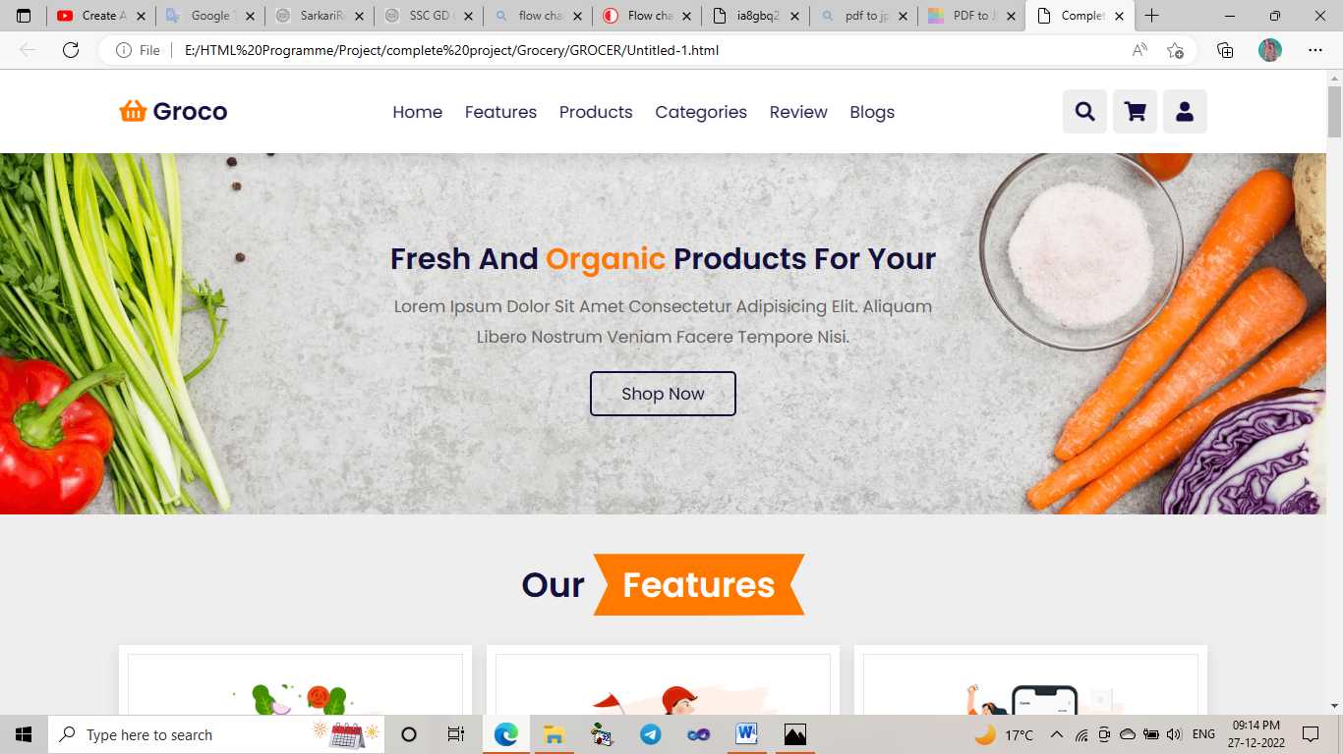

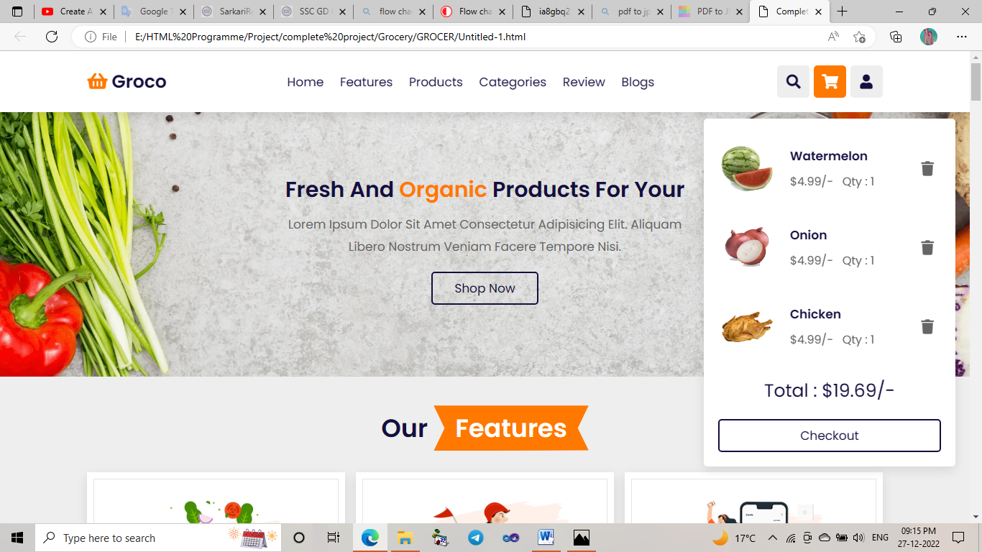

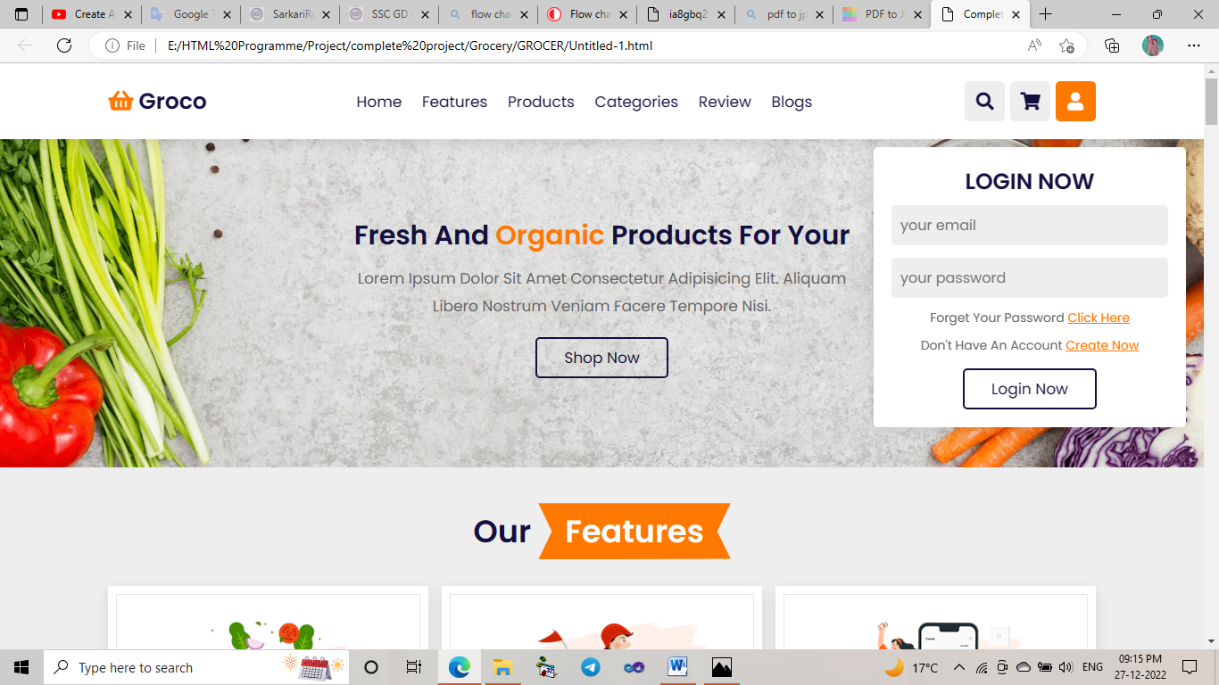

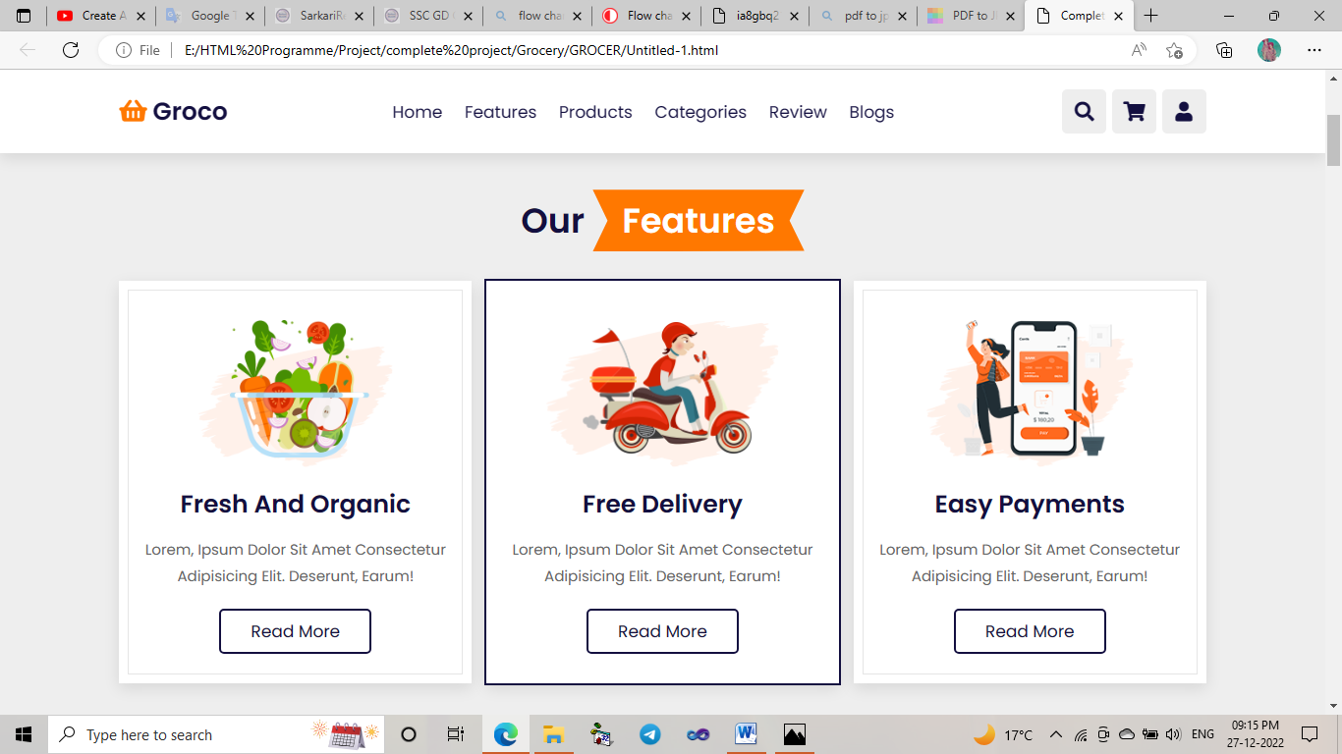

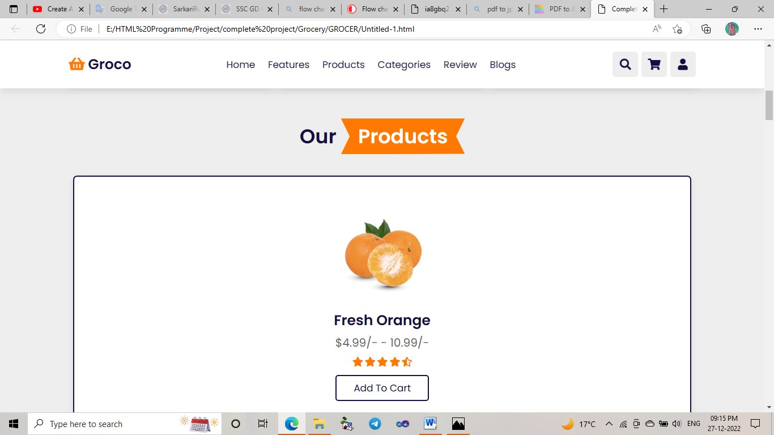

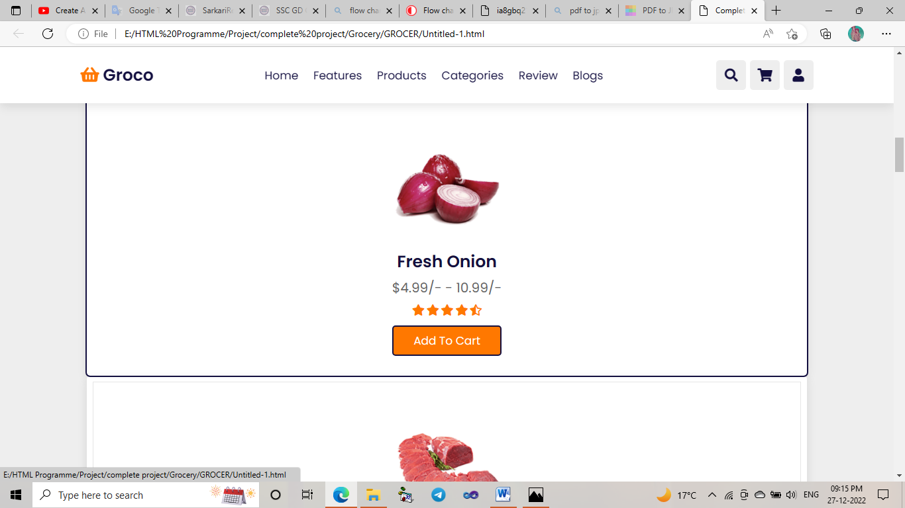

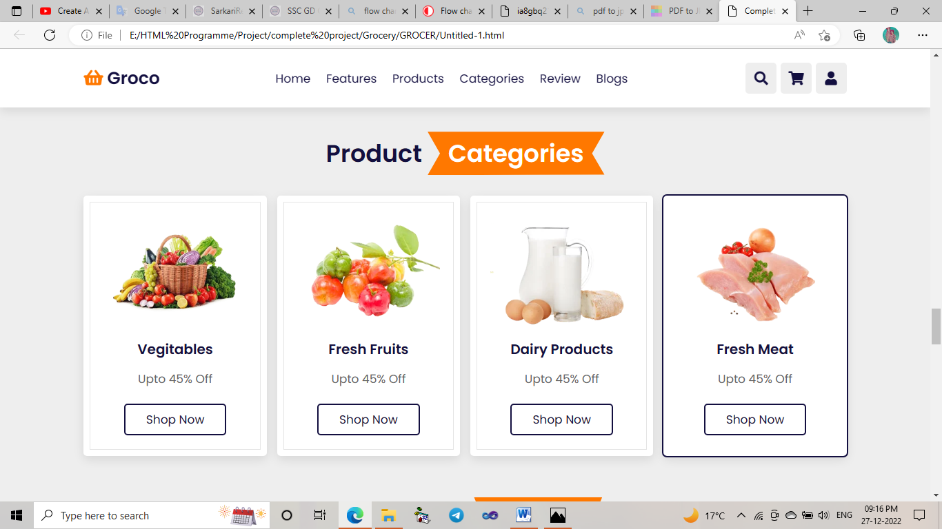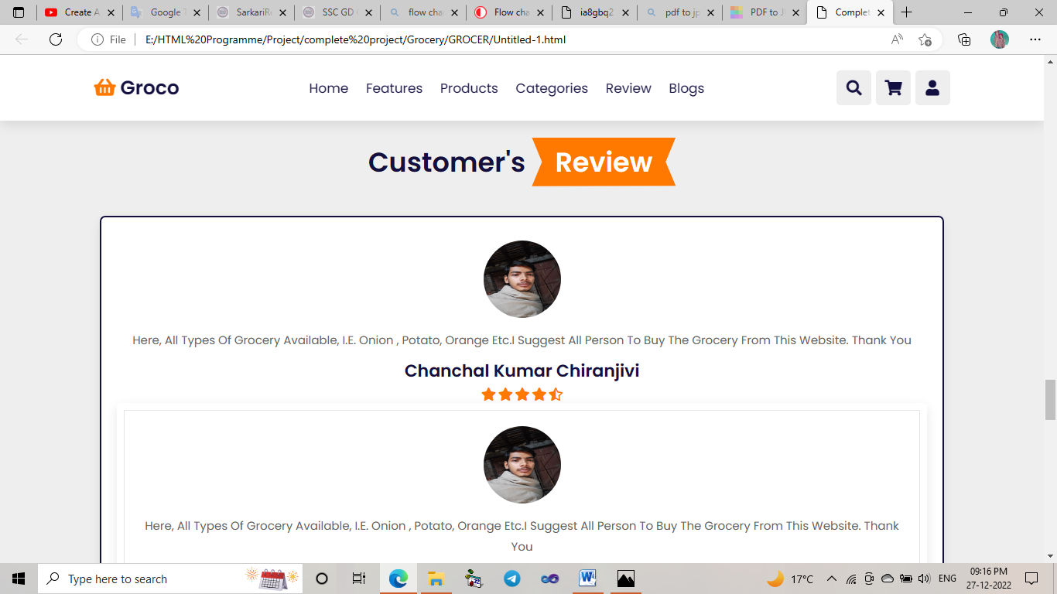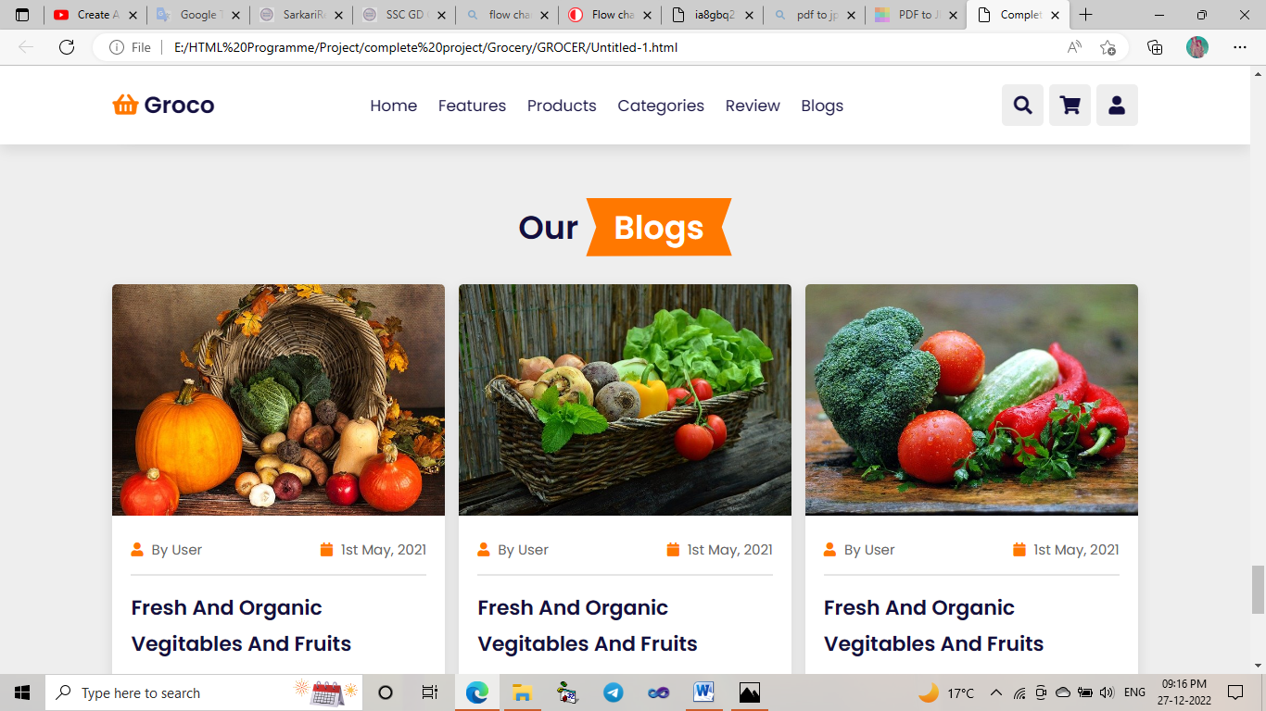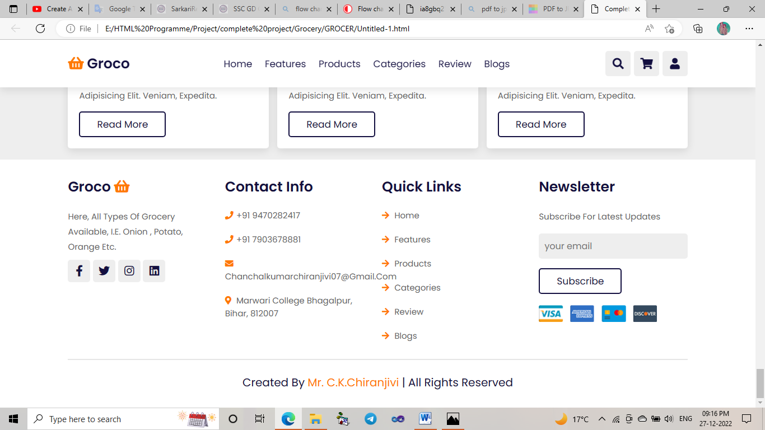

**Helping Bibliography**

1. HTML ,CSS , JavaScript
2. www.Javatpoint.com
3. YouTube
4. Teacher of Marwari College.